Pizza Sales SQL Query

A. KPI’s
1. Total Revenue
SELECT SUM(total_price) AS Total_Revenue FROM pizza_sales
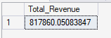
2. Average order value
SELECT SUM(total_price) / COUNT(DISTINCT order_id) AS Avg_Order_Value
FROM pizza_sales
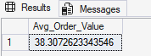
3. Total Pizza Sold
SELECT SUM(quantity) AS Total_Pizza_Sold
FROM pizza_sales
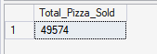
4. Total Orders
SELECT COUNT(DISTINCT order_id) AS Total_Orders
FROM pizza_sales
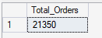
5. Average Pizzas Per Order
SELECT CAST(CAST(SUM(quantity) AS DECIMAL(10, 2)) /
CAST(COUNT(DISTINCT order_id) AS DECIMAL(10, 2)) AS DECIMAL(10, 2))
AS Avg_Pizzas_Per_Order FROM pizza_sales
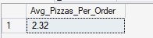
6. Daily Trend for Total orders
SELECT DATENAME(DW, order_date) AS Order_Day, COUNT(DISTINCT order_id) AS Total_Orders
FROM pizza_sales
GROUP BY DATENAME(DW, order_date)
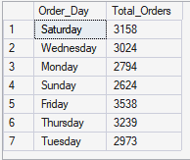
7. Monthly Trend for Total orders
SELECT DATENAME(MONTH, order_date) AS Order_Month, COUNT(DISTINCT order_id) AS Total_Orders
FROM pizza_sales
GROUP BY DATENAME(MONTH, order_date)
ORDER BY Total_Orders DESC
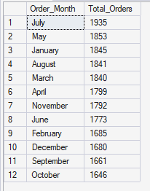
8. Hourly Trend for orders

SELECT DATEPART(HOUR, order_time) AS order_hours,
COUNT(DISTINCT order_id) AS total_orders
FROM pizza_sales
GROUP BY DATEPART(HOUR, order_time)
ORDER BY DATEPART(HOUR, order_time)
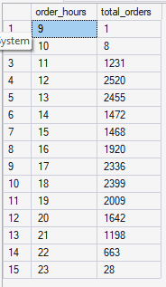
9. Percentage of Sales by Pizza Category for January
/* This is for January Month*/

SELECT pizza_category, SUM(total_price) AS Total_sales,
SUM(total_price) * 100 / (SELECT SUM(total_price) FROM pizza_sales WHERE MONTH(order_date) = 1) AS Percentage_Total_Sales
FROM pizza_sales
WHERE MONTH(order_date) = 1
GROUP BY pizza_category
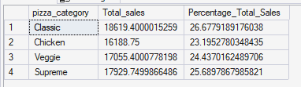
10. Percentage of Sales by Pizza Size for 1st quarter
A quarter divides a year into 4 parts:
- Q1 → January, February, March
- Q2 → April, May, June
- Q3 → July, August, September
- Q4 → October, November, December

SELECT pizza_size, CAST(SUM(total_price) AS DECIMAL(10, 2)) AS Total_sales,
CAST(SUM(total_price) * 100 /
(SELECT SUM(total_price) FROM pizza_sales WHERE DATEPART(quarter, order_date) = 1) AS DECIMAL(10, 2)) AS Percentage_Total_Sales
FROM pizza_sales
WHERE DATEPART(quarter, order_date) = 1
GROUP BY pizza_size
ORDER BY Percentage_Total_Sales DESC
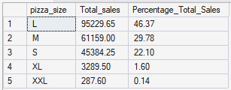
11. Top 5 best sellers by Revenue,
SELECT TOP 5 pizza_name, CAST(SUM(total_price) AS DECIMAL(10, 2)) AS Total_Revenue
FROM pizza_sales
GROUP BY pizza_name
ORDER BY Total_Revenue DESC
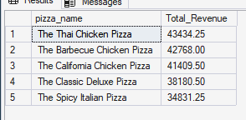
12. Top 5 best sellers by Total Quantity
SELECT TOP 5 pizza_name, CAST(SUM(quantity) AS DECIMAL(10, 2)) AS Total_Quantity
FROM pizza_sales
GROUP BY pizza_name
ORDER BY Total_Quantity DESC
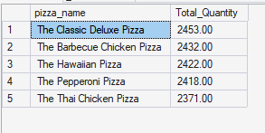
13. Top 5 sellers by Orders
SELECT TOP 5 pizza_name, COUNT(DISTINCT order_id) AS Total_Orders
FROM pizza_sales
GROUP BY pizza_name
ORDER BY Total_Orders DESC
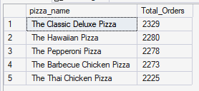
14. Bottom 5 sellers by Revenue
SELECT TOP 5 pizza_name, CAST(SUM(total_price) AS DECIMAL(10, 2)) AS Total_Revenue
FROM pizza_sales
GROUP BY pizza_name
ORDER BY Total_Revenue ASC
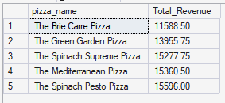
15. Bottom 5 sellers by Total Quantity
SELECT TOP 5 pizza_name, CAST(SUM(quantity) AS DECIMAL(10, 2)) AS Total_Quantity
FROM pizza_sales
GROUP BY pizza_name
ORDER BY Total_Quantity
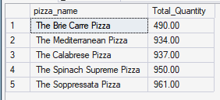
16. Bottom 5 sellers by Orders
SELECT TOP 5 pizza_name, COUNT(DISTINCT order_id) AS Total_Orders
FROM pizza_sales
GROUP BY pizza_name
ORDER BY Total_Orders
